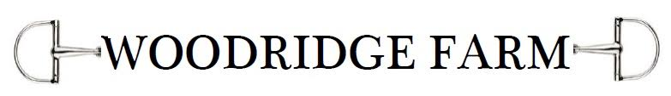
Lesson Program
Enrollment Form

Contact Information

Parent’s Name: _________________________________________________________________________________

Address: _________________________________________________________________________________________

Town: _______________________________________ Zip: ______________________________________________

Phone Number (home): ____________________________________ (cell): ____________________________

Email Address: ___________________________________________________________________________________

Rider Information

Name: __________________________________________________________

Age: _____________________________________________________________

Allergies (if any): ______________________________________________

Riding level (please circle one):

Beginner = never ridden.
Advanced beginner = Previous riding lessons; walking and trotting independently.
Experienced beginner = Previous riding lessons; walking, trotting, and cantering independently; and is interested in horse showing.

For more information please contact
Alixe Schwartz
(978) 273-6963
schwizortz@gmail.com

