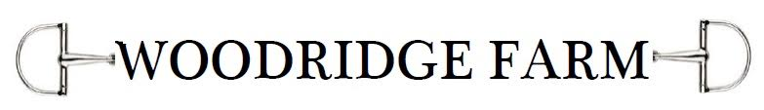

Lesson Packages
•Pay as you go. $90
•8 Lessons (paid up front) $680
must complete with in a 4 week time frame
•4 Lessons (paid up front) $350
must complete with in a 2 week time frame
Cancellation Policy
•24 hour notice or full price of lesson
•If cancelled, make up lesson within next week

